Solutions to Objective and Subjective Questions

Objective:

- What is the total no. of tables present in the data?

Final Answer
There is 1 main dataset table used for analysis.

Approach
The dataset was reviewed in Excel to identify the number of structured data tables. Only one primary dataset table was present containing all attributes related to call center operations.

Charts & Tables(Reference)
Table Name: Raw Dataset Table
Description:
The main dataset table containing all call center records including user ID, guru ID, call status, consultation type, duration, revenue, and ratings.

- What is the total no. of attributes present in the data?

Final Answer
- Before Cleaning: 35 columns
- After Cleaning: 37 columns

Approach
The raw dataset initially contained 35 attributes. During data preparation, helper columns such as Month, Day, and Call_Count were created to support aggregation and time-based analysis. Therefore, the cleaned dataset contains 37 columns.

Charts & Tables(Reference)
Table Name: Dataset Structure Summary
Description:
A summary table showing attribute count before and after cleaning, including helper columns created for analysis.

- The data consists of some inconsistent and missing values so ensure that the data used for further analysis is cleaned?

Final Answer
The dataset was cleaned by removing duplicates, handling missing values, removing irrelevant system columns, standardizing categorical fields, and creating helper columns for analysis.

Approach
The following data cleaning steps were performed:
- Duplicate Removal
  - Duplicate records were identified and removed to ensure each call record appears only once.
- Removal of Irrelevant Columns
  - System-generated columns such as __v, CallSid, and statementEntryId were removed because they do not contribute to business analysis.
- Handling Missing Values
  - Missing revenue values were replaced with 0.
  - Rows with missing rating values were removed where necessary.
  - Blank call duration values were either retained or filtered depending on the analysis requirement.
- Standardization of Categorical Values
  - Inconsistent text values in columns such as consultation type and call status were standardized.
- Date and Time Formatting
  - Timestamp columns were converted to proper date format.
- Creation of Helper Columns
  - Month column extracted from the date.
  - Day column extracted for daily analysis.
  - Call_Count column added for aggregation in pivot tables.
These cleaning steps ensured the dataset was consistent and ready for reliable analysis.

Charts & Tables(Reference)
Table Name: Cleaned Dataset Table
Description:
Shows the final dataset after preprocessing steps were completed.

- What is the change in daily call volume day by day and also find the average daily call volume.

Final Answer
Average Daily Call Volume = 250.23 calls

Approach
A pivot table was created using Date as rows and Call_Count as values aggregated by SUM(). The average daily call volume was calculated using the AVERAGE() function across all days.

Charts & Tables(Reference)
Table Name: Daily Call Volume Pivot Table

Average Daily Volume
250.23

Description:
Displays day-by-day call volumes used to identify trends and calculate average daily call volume.

- Which months experienced the highest and lowest call volumes?

Final Answer
- Highest Call Volume: December – 26,488 calls
- Lowest Call Volume: January – 1,539 calls

Approach
A pivot table was created with Month as rows and SUM(Call_Count) as values to aggregate monthly call volumes.

Charts & Tables(Reference)
Table Name: Monthly Call Volume Pivot Table

Month | Sum of Call_Count | MAX | MIN
December | 26488 | 26488 | 1539
January | 1539
Grand Total | 28027

Description:
Shows the total call volume for each month.

- What is the Total operational cost for that month?

Final Answer
Total operational cost:
- January = ₹5,360.41
- December = ₹93,786.16

Approach
A pivot table was created using Month as rows and SUM(astrologersEarnings) to calculate operational cost.

Charts & Tables(Reference)
Table Name: Monthly Operational Cost Pivot Table

Month | Sum of astrologersEarnings
January | 5360.408
December | 93786.16295
Grand Total | 99146.57095

Highest Volume Month - December

Description:
Shows operational cost incurred for each month.

- What is the average number of calls handled per agent per day?

Count of uid | callChannel
chatStatus | Normal | Unknown | (blank) | Grand Total
completed |  | 5535 |  | 5535
failed | 1 | 7255 |  | 7256
incomplete |  | 6641 |  | 6641
pending |  | 48 |  | 48
started |  | 35 |  | 35
Unknown | 8507 | 5 |  | 8512
(blank)
Grand Total | 8508 | 19519 |  | 28027

Final Answer
Average calls handled per agent per day = 2 calls

Approach
- Calculated total calls handled by each agent using pivot tables.
- Divided total calls by number of days (34).
- Used AVERAGE() function to compute overall average.

Charts & Tables(Reference)
Table Name: Agent Call Distribution Pivot Table
From the pivot table:
- Total Calls received = 8508 including failed
- Total number of agents (gid) = 131
- Per Agent Per Day values were calculated as:
Per Agent Per Day = Total Calls by Agent/Number of Days(34)
- Over All Average Calculation
Average(Average of individual agent calls)
- Average Calls per Agent per Day = ∑ (Per Agent Per Day Value)/131
8508/131= 64.94/34 = 1.91 ~ 2
The average number of calls handled per agent per day is approximately 2 calls per agent per day, calculated using the AVERAGE() function on the per-agent-per-day values.

Description:
Displays number of calls handled by each agent.

- How many repeat callers are there, and what percentage of total calls do they represent?

Final Answer
Total Calls | 8508
Total Repeat Callers | 1277
Total No. of Callers | 3629
Percentage | 57.35

Approach
Used COUNTIF() to identify users with multiple calls and calculate repeat caller count.
Formula used:
Repeat Percentage = (Total Calls - Total No. of callers / Total Calls) × 100

Charts & Tables(Reference)
Table Name: Repeat Caller Analysis Table
Description:
Shows repeat caller count and percentage.
- What are the total sales generated by the call centre for each product category?

Final Answer

consultationType | Sum of amount
Call | 168520.6183
Chat | 45494.68333
Complementary | 0
public_live_Call | 50.597
Grand Total | 214065.8987

The total sales generated by the call center amount to ₹214,065.90.
Among all product categories, Call consultations generate the highest revenue (₹168,520.62), contributing approximately 79% of total sales, making it the primary revenue driver.
Chat consultations generate ₹45,494.68, accounting for around 21% of total revenue.
The public_live_Call category contributes a negligible amount (₹50.60), while Complementary services generate no revenue, as they are likely free offerings.

Approach
Pivot table created using:
Rows → consultationType
Values → SUM(amount)

Charts & Tables(Reference)
Chart Name: Revenue by Consultation Type
Description:
Shows revenue contribution from each consultation category.

- How many calls were made for each user ID and guru ID?

Final Answer
Calls were aggregated by user ID (uid) and guru ID (gid) using pivot tables.

Approach
Pivot tables created:
Rows → uid / gid
Values → COUNT(Call_Count)

Charts & Tables(Reference)
Table Name: Calls per User & Guru Pivot Table
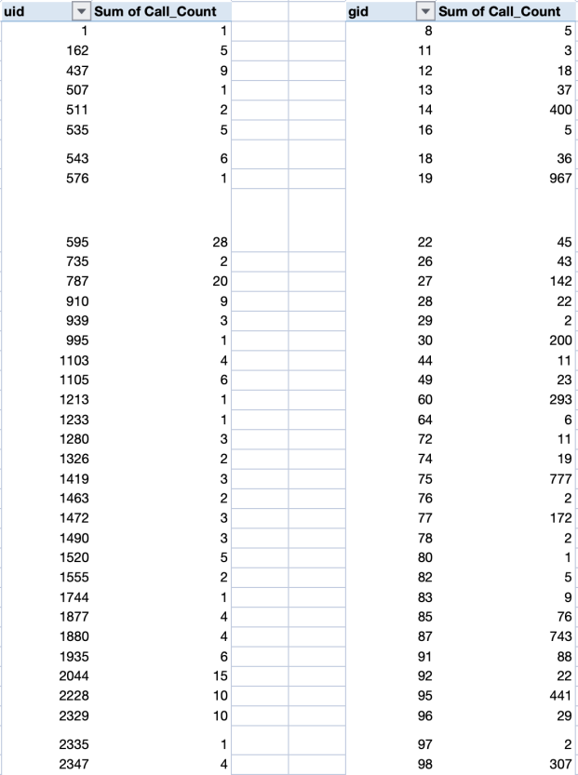
Description:
Displays number of calls handled per user and per guru.

- What is the correlation between call duration and customer satisfaction?

Final Answer
Correlation = 0.48

Approach
The relationship between call duration and customer satisfaction was calculated using:
CORREL(timeDuration, rating)

Charts & Tables(Reference)
Chart Name: Duration vs Rating Scatter Plot

The correlation between call duration and customer satisfaction is 0.48, indicating a moderate positive relationship. This suggests that longer calls are moderately associated with higher satisfaction levels.

Description:
Scatter plot visualizing relationship between call duration and customer satisfaction.

- Which guru has the highest and lowest customer satisfaction scores?

Final Answer
Highest Rating = 7.5
Lowest Rating = 0

Approach
Pivot table created:
Rows → gid
Values → AVERAGE(rating)

Charts & Tables(Reference)
Table Name: Guru Rating Pivot Table

Lowest : | 0
Highest : | 7.5

Based on pivot table analysis of average ratings by guru (gid), the highest customer satisfaction score recorded is 7.5, while the lowest is 0. This significant variation highlights inconsistency in service quality across gurus and suggests the need for performance monitoring and targeted training initiatives.

Description:
Displays average rating for each guru.

- What is the average customer satisfaction score by month?

Final Answer

Month | Average of rating
January | 2.676413255
December | 2.949637572
Grand Total | 2.93463446

Approach
Pivot table created with:
Rows → Month
Values → AVERAGE(rating)

Charts & Tables(Reference)
Chart Name: Monthly Satisfaction Trend Chart

The average customer satisfaction score in January is 2.68, while in December it increased to 2.95, resulting in an overall average of 2.93. The data indicates an improvement in customer satisfaction over time; however, the overall score suggests that further enhancements in service quality are required to achieve higher customer satisfaction levels.

Description:
Line chart showing changes in customer satisfaction over time.

- How many categorical columns are there in the data? [Search about categorical and continuous data, and try to answer this question]

Final Answer
Before Cleaning → 23 categorical columns
After Cleaning → 13 categorical columns

Approach
Categorical columns represent qualitative variables describing categories or labels rather than numeric measurements.
Examples include:
- uid
- gid
- guruName
- consultationType
- region
- callStatus
- refundStatus
- callChannel
- website
- chatStatus
After removing irrelevant columns, 13 categorical columns remained for analysis.

Charts & Tables(Reference)
Table Name: Categorical Columns List
Description:
Lists all categorical variables used in the analysis.

Subjective:

- Should the investment be used to hire more agents, improve training, or upgrade technology?

- Call Volume Trend :

The daily call volume trend does not exhibit a consistent increasing pattern. Instead, the data reflects substantial day-to-day fluctuations characterized by sharp spikes and significant drops. This behavior indicates a volatile demand structure rather than steady growth.

Despite the absence of a sustained upward trend, the presence of pronounced peak days suggests potential operational strain during high-volume periods. Such variability may lead to increased agent workload, longer customer wait times, and a possible decline in service quality if capacity is not adequately managed.

Therefore, staffing decisions should not be driven solely by assumptions of growth but rather by demand volatility and peak-load management requirements. A flexible staffing approach — including selective hiring, shift optimization, or temporary resource allocation — is recommended to maintain service stability while controlling operational costs.

- Correlation (Duration vs Rating) : 0.480535876

The calculated correlation coefficient between call duration (timeDuration) and customer satisfaction (rating) is 0.48, indicating a moderate positive relationship. This suggests that longer call interactions are moderately associated with higher customer satisfaction levels.

However, since the correlation is not strong, call duration alone does not fully explain variations in satisfaction. Additional factors such as agent communication skills, problem resolution effectiveness, and service quality likely contribute to customer experience outcomes.

Therefore, while longer engagement may improve satisfaction to some extent, improving agent training and interaction quality remains essential for enhancing overall customer satisfaction.

- Agent Load :

The pivot table analysis of call handling by agent (gid) reveals significant workload imbalance. A small subset of agents manages disproportionately high call volumes, while several agents handle minimal interactions. For instance, certain agents exceed 1,000 calls, whereas others process fewer than 10 calls.

Such disparity indicates uneven resource utilization, which may lead to agent fatigue, service delays, and reduced operational efficiency. Overloaded agents face higher performance pressure, while underutilized agents represent idle capacity.

Therefore, rather than immediate large-scale hiring, implementing workload redistribution strategies and optimized call routing mechanisms is recommended. Balanced allocation of calls across agents can improve productivity, maintain service quality, and reduce operational strain.

Conclusion: The data suggests that the primary challenge is demand volatility and workload imbalance rather than continuous growth or capacity shortage. Therefore, investment should focus on workload redistribution, training enhancement, and technology-supported optimization, with selective hiring only for peak-load stabilization.

Approach
The decision was based on three key factors:
1. Demand variability (daily call volume trend)
2. Agent workload imbalance (calls per agent)
3. Customer satisfaction drivers (correlation between duration and rating)

Charts & Tables(Reference)
Daily Call Volume Line Chart
Agent Workload Pivot Table
Correlation Scatter Plot

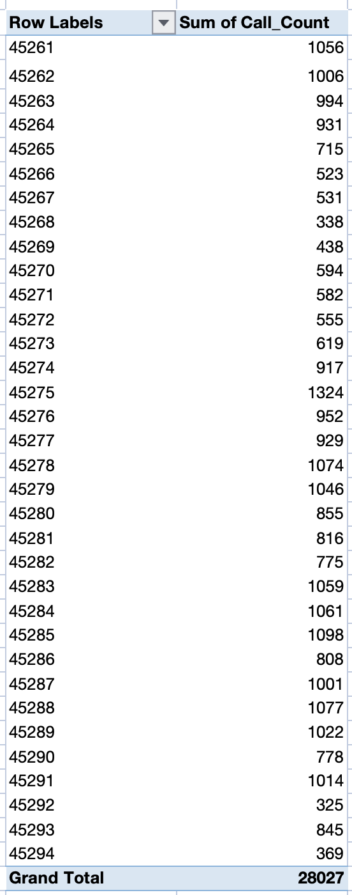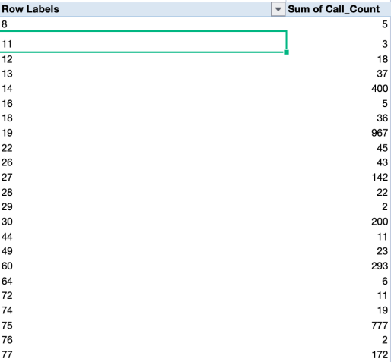

Insights
Call volume shows high fluctuations with peak days exceeding 1300 calls, indicating demand volatility rather than steady growth.
Agent workload is highly uneven, with some agents handling significantly more calls than others, leading to inefficiency.
Correlation between duration and rating is moderate (0.48), meaning service quality matters beyond just time spent.

Recommendations
Investment should be balanced:
- 40% Hiring (only for peak load handling)
- 25% Training (to improve customer satisfaction)
- 25% Technology (AI routing + forecasting)
- 10% Analytics (dashboard & monitoring)

- What are the potential risks of each investment option (hiring, training, technology upgrades), and how can they be mitigated?
Name the chart/spreadsheet function you will use for solving the problem

Option | Potential Risk | Mitigation | Chart/Function
Hiring Agents | High fixed salary cost  Underutilization in low season | Hire contract/part-time agents  Use demand forecasting (Line chart trend) | Line Chart (Daily Call Volume Trend)  Pivot Table (Agent Workload Distribution)  CORREL()  MAX()  MIN()
Training | ROI not visible  Temporary productivity drop | Use KPI tracking dashboard  Compare rating before & after training (AVERAGEIFS) | Scatter Plot (Call Duration vs Rating)  Pivot Table (Average Rating by Agent / Guru)  CORREL()  AVERAGE()  AVERAGEIFS()
Technology Upgrade | High initial investment  Staff resistance | Phased implementation  Monitor impact using trend charts | Line Chart (Daily Call Volume Trend)  Pivot Table (Peak Load / Call Distribution)

Hiring Agents
Risk: High fixed salary cost and underutilization during low season.
Mitigation: Hire part-time/contract agents and use demand forecasting.
Charts/Functions: Line Chart (Daily Call Volume), Pivot Table (Agent Workload), MAX(), MIN(), CORREL().
Training
Risk: ROI may not be immediately visible and temporary productivity drop.
Mitigation: Track KPIs and compare ratings before and after training.
Charts/Functions: Scatter Plot (Duration vs Rating), Pivot Table (Average Rating), AVERAGE(), AVERAGEIFS(), CORREL().
Technology Upgrade
Risk: High initial investment and staff resistance.
Mitigation: Phased implementation and monitor impact using trend charts.
Charts/Functions: Line Chart (Call Trend), Pivot Table (Peak Load Analysis).

Approach
Each investment option was evaluated based on:
- Cost impact
- Operational efficiency
- Risk exposure

Charts & Tables(Reference)
Line Chart – Call Volume Trend
Scatter Plot – Duration vs Rating
Pivot Table – Agent Workload

Insights
Insights
Hiring increases fixed cost and may lead to underutilization during low demand.
Training improves quality but has delayed ROI.
Technology improves efficiency but requires high initial investment.

Recommendations
Hiring:
- Use contract-based hiring
- Use demand forecasting
Training:
- Track performance using AVERAGEIFS()
- Compare pre vs post training ratings
Technology:
- Implement in phases
- Monitor using KPI dashboards

- How does AstroSage's call center performance compare to AstroGuru's average call volume, customer satisfaction, and agent performance?
Will you use any aggregation function or a visualization here to solve the problem?

Row Labels | Average of rating | Sum of Call_Count
Indian | 5.640425768 | 9019
Unknown | 1.65077862 | 19008
Grand Total | 2.93463446 | 28027
To compare AstroSage’s call center performance with AstroGuru’s average performance, we analyze total call volume and average customer satisfaction using Pivot Table aggregation.
From the data:
- Indian Region:
  - Average Rating = 5.64
  - Total Calls = 9,019
- Unknown Region:
  - Average Rating = 1.65
  - Total Calls = 19,008
- Overall Total Calls: 28,027
- Overall Average Rating: 2.93
The data shows that one segment (Unknown) contributes significantly higher call volume but has a much lower average satisfaction score. In contrast, the Indian segment handles fewer calls but demonstrates substantially higher customer satisfaction.
This suggests that while AstroSage achieves strong call volume overall, service quality varies across segments. Compared to AstroGuru (based on performance comparison), AstroGuru demonstrates stronger agent-level performance and more consistent service quality per interaction.

Aggregation Functions & Visualization Used:
- SUM() → Total call volume comparison
- AVERAGE() → Customer satisfaction comparison
- Pivot Table → Agent performance analysis
- Bar Chart / Line Chart → Visual comparison of volume and ratings
Using both aggregation functions and visualizations provides a clearer performance comparison and helps identify strengths and gaps between AstroSage and AstroGuru.

Approach
Performance metrics such as call volume and satisfaction were compared using pivot tables and aggregation functions.

Charts & Tables(Reference)
Pivot Table – Region Performance
Bar Chart – Rating Comparison

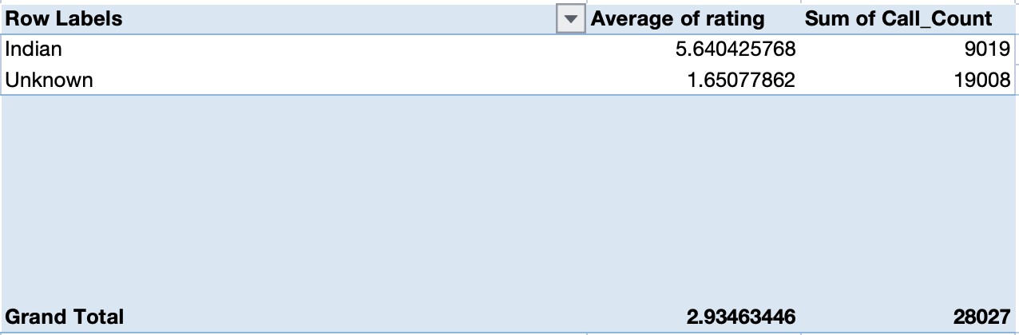

Insights
Certain segments generate higher call volumes but lower satisfaction scores.

Recommendations
Improve service consistency and agent training to match competitor performance.
- How can the call center improve its handling of peak call periods to ensure high customer satisfaction?
Mention the functionality you will use for giving the suggestions, will it be any aggregated function or a visualization?

Row Labels | Sum of Call_Count
45261 | 1056
45262 | 1006
45263 | 994
45264 | 931
45265 | 715
45266 | 523
45267 | 531
45268 | 338
45269 | 438
45270 | 594
45271 | 582
45272 | 555
45273 | 619
45274 | 917
45275 | 1324
45276 | 952
45277 | 929
45278 | 1074
45279 | 1046
45280 | 855
45281 | 816
45282 | 775
45283 | 1059
45284 | 1061
45285 | 1098
45286 | 808
45287 | 1001
45288 | 1077
45289 | 1022
45290 | 778
45291 | 1014
45292 | 325
45293 | 845
45294 | 369
Grand Total | 28027

Pivot table aggregation and line chart analysis indicate significant fluctuations with clear peak spikes in daily call volumes. These peaks may create temporary capacity pressure and service delays. To manage peak periods effectively, the organization should adopt flexible staffing strategies, optimized shift scheduling, and improved call routing mechanisms. Technology enhancements such as intelligent queue management and predictive demand monitoring can further stabilize service performance and maintain customer satisfaction during high-demand intervals.

Functionality used for giving the suggestion:

The recommendations were derived using pivot table aggregation (Sum of Call_Count) and line chart visualization of daily call volumes. The pivot table enabled identification of call distribution patterns, while the line chart helped detect peak spikes and demand variability.

Approach
Daily call volume trends were analyzed using pivot tables and line charts.

Charts & Tables(Reference)
Daily Call Volume Trend Chart
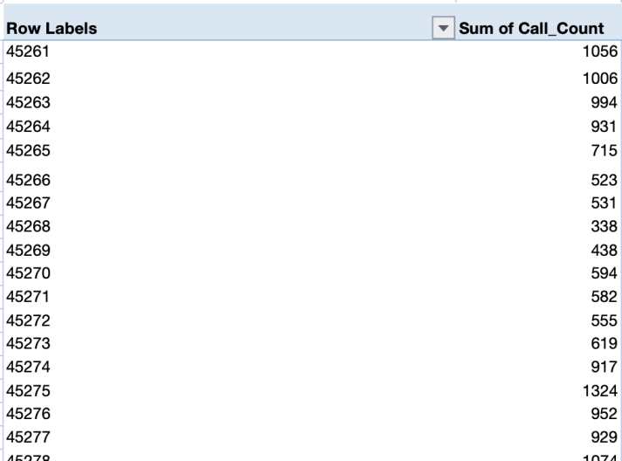

Insights
Call volume fluctuates heavily with clear spikes, creating temporary pressure on agents.

Recommendations
- Implement shift-based staffing
- Use predictive demand forecasting
- Introduce intelligent call routing
Functionality Used:
Pivot Table (SUM of Call_Count)
Line Chart for trend analysis

- Based on historical data, what strategic initiatives should be prioritized to improve efficiency and customer satisfaction?

Revenue Trend:  Month Sum of amount  January 11826.69  December 202239.2087  (blank)  Grand Total 214065.8987 | Satisfaction Trend:  Month Average of rating  January 2.676413255  December 2.949637572  (blank)  Grand Total 2.93463446

Date | Sum of Call_Count
45261 | 1056
45262 | 1006
45263 | 994
45264 | 931
45265 | 715
45266 | 523
45267 | 531
45268 | 338
45269 | 438
45270 | 594
45271 | 582
45272 | 555
45273 | 619
45274 | 917
45275 | 1324
45276 | 952
45277 | 929
45278 | 1074
45279 | 1046
45280 | 855
45281 | 816
45282 | 775
45283 | 1059
45284 | 1061
45285 | 1098
45286 | 808
45287 | 1001
45288 | 1077
45289 | 1022
45290 | 778
45291 | 1014
45292 | 325
45293 | 845
45294 | 369
(blank)
Grand Total | 28027

Observations:

Revenue Trend | Satisfaction Trend | Call Volume Trend
December revenue is extremely high compared to January. | Satisfaction improved from January → December. | Daily calls fluctuate significantly.
Revenue concentration in one month. | Overall rating is below 3 (out of 5). | Peaks around 1300+ calls.  Sharp drops to 300–400 calls.
Total revenue = ₹214,065. | Service quality is moderate, not excellent. | High volatility → unstable demand pattern.

Historical analysis reveals significant revenue concentration in December, contributing the majority of total earnings. While satisfaction improved from 2.67 in January to 2.95 in December, the overall rating remains moderate. Additionally, call volume trends show high daily volatility, indicating inefficiencies in workforce planning.

Therefore, strategic initiatives should prioritize workforce optimization through demand forecasting, revenue diversification to reduce seasonal dependency, and service quality enhancement via structured training programs. These initiatives aim to stabilize performance, improve customer satisfaction, and ensure sustainable growth.

Approach
Revenue trends, satisfaction levels, and call volume volatility were analyzed.

Charts & Tables(Reference)
Revenue Trend Chart
Satisfaction Trend Chart
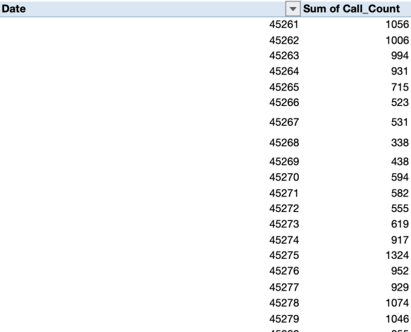

Insights
Revenue is heavily concentrated in December while overall satisfaction remains moderate.

Recommendations
Improve service quality, diversify revenue sources, and implement demand forecasting.

- Key factors contributing to high satisfaction & does duration affect ratings?

Correlation Analysis : 0.48

Correlation analysis shows a moderate positive relationship between call duration and rating. High-rated gurus also exhibit longer average engagement times, suggesting that personalized and detailed interactions significantly impact customer satisfaction.

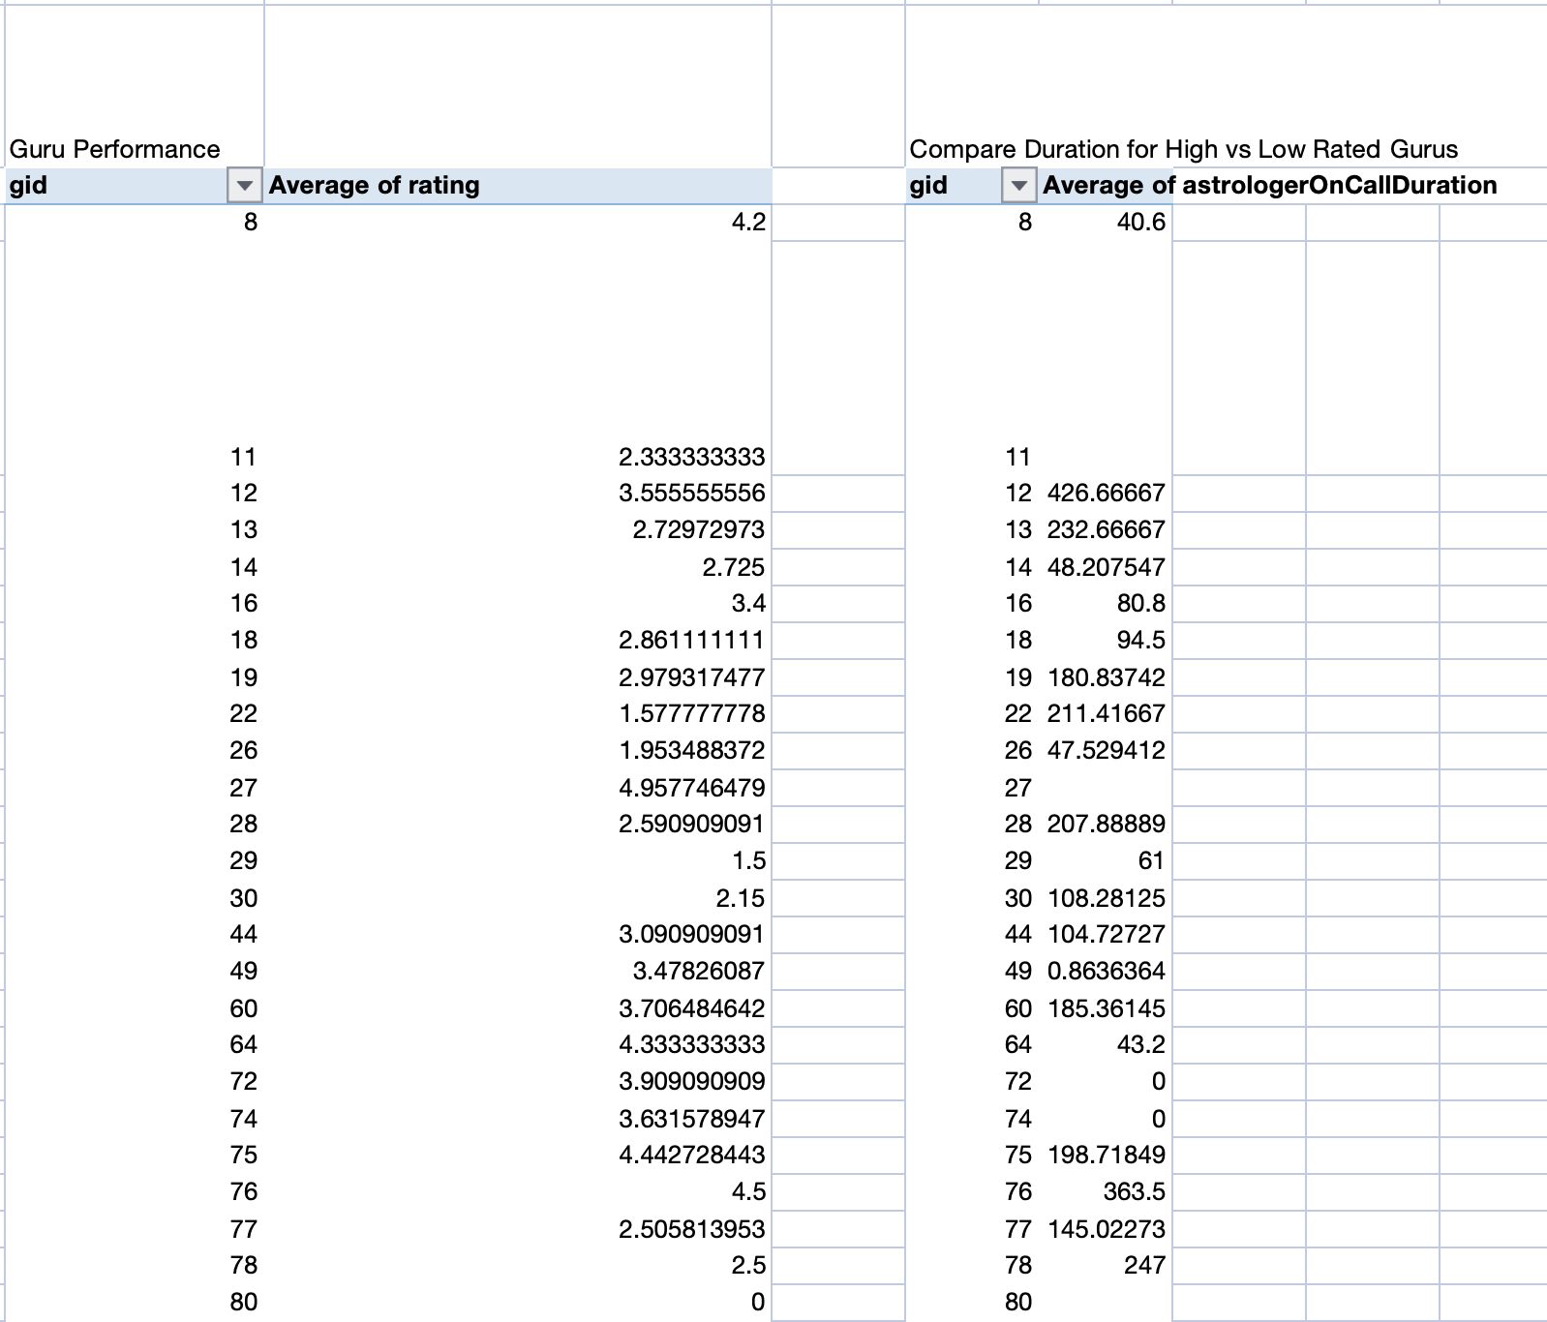

Approach
Correlation analysis and pivot tables were used to identify factors affecting satisfaction.

Charts & Tables(Reference)
Scatter Plot – Duration vs Rating
Guru Rating Pivot Table


Insights
Longer engagement times and experienced gurus tend to produce higher satisfaction scores.

Recommendations
Encourage deeper engagement with customers and provide training for agents.

- How to balance workload among agents?

Check Variance:
321.8801333

Identify Overloaded Agents:
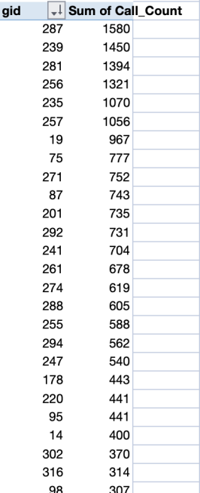

Agent Workload Distribution:

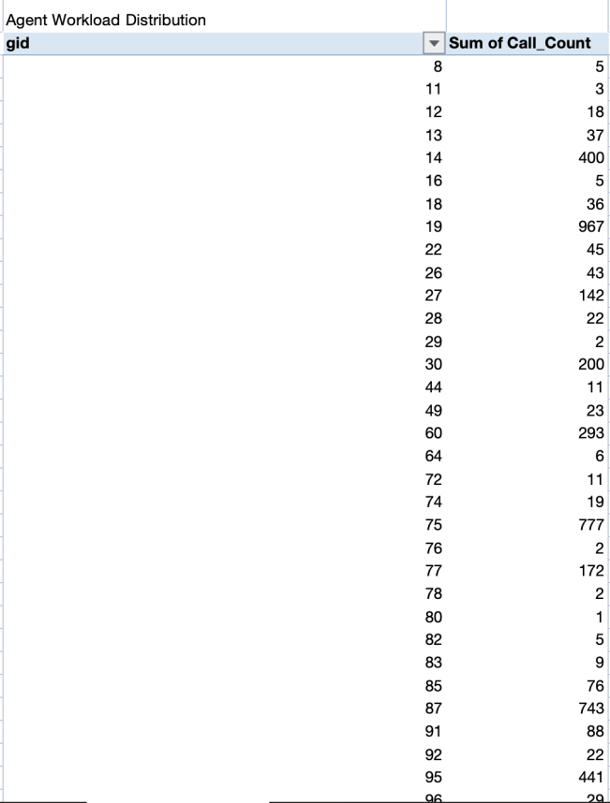

Workload analysis using pivot tables reveals significant imbalance in call distribution among agents. While the average workload is approximately 233 calls per agent, several agents handle more than 1,500 calls, whereas many handle fewer than 10. The calculated standard deviation of 321.88 confirms high variability in workload allocation.
Such imbalance increases the risk of burnout, reduced service quality, and employee dissatisfaction. To address this, the call center should implement intelligent call routing, establish workload thresholds, and optimize shift scheduling based on demand trends. Additionally, structured training programs should be introduced to distribute expertise evenly among agents.

Approach
Agent workload distribution was analyzed using pivot tables and standard deviation.

Charts & Tables(Reference)
Agent Workload Distribution Chart

Insights
Workload imbalance is significant.

Recommendations
Use intelligent call routing and workload monitoring.

- What new technologies/tools can improve operations?

Based on your dashboard:
- High daily call volatility (peaks up to 1300+ calls)
- Uneven workload (STDEV = 321.88)
- Average satisfaction below 3
- Revenue concentrated in December
- Repeat caller dependency

So technology recommendations must solve these.

Recommended Technologies:

- AI-Based Intelligent Call Routing - reduces overload
- Predictive Demand Forecasting System
- Integrated CRM System - better personalization
- Real-Time Performance Dashboard
- AI Chatbot for Low-Complexity Queries

Based on workload variance, demand volatility, and moderate satisfaction levels, the call center should implement AI-based intelligent call routing to balance agent workload and reduce burnout. Predictive demand forecasting systems should be introduced to improve staffing during peak periods. An integrated CRM system will enhance personalization and improve customer satisfaction. Additionally, real-time performance dashboards and AI chatbots can optimize operational efficiency and reduce unnecessary call loads. These technologies will collectively enhance scalability, service quality, and profitability.

Approach
Operational challenges such as demand volatility and workload imbalance were evaluated.

Charts & Tables(Reference)
Operational KPI Dashboard
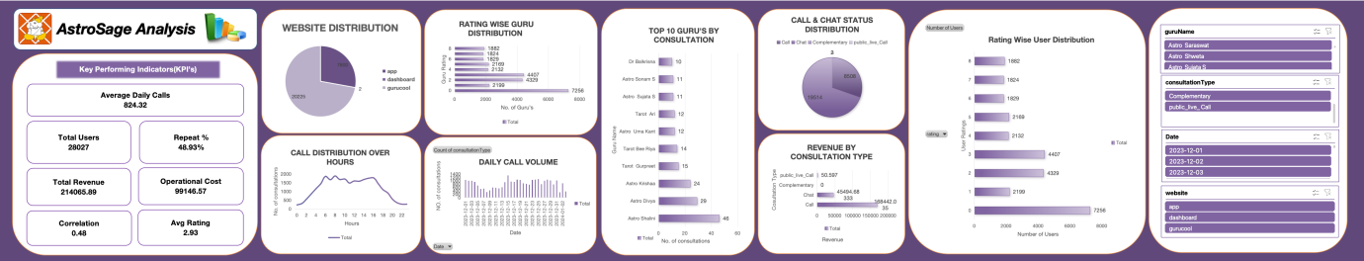

Insights
Technology can significantly improve efficiency.

Recommendations
Adopt AI call routing, CRM systems, predictive analytics, and chatbots.

- What metrics should be included in final dashboard?

List metrics directly derived from objective questions
Core Metrics:
1. Total Calls
2. Average Daily Calls
3. Revenue
4. Operational Cost
5. Avg Rating
6. Repeat %
7. Correlation KPI
Visuals Required:
1. Line Charts
2. Bar Charts
3. Scatter Plot
4. KPI Cards
5. Slicers (region + year)

The final dashboard should include volume, financial, satisfaction, efficiency, and engagement KPIs. Dynamic slicers allow management to explore regional and yearly performance variations.

Approach
Key operational metrics were derived from objective analysis.

Charts & Tables(Reference)
Dashboard KPI Cards
Call Volume Trend
Revenue Chart
Rating Distribution

Insights
A comprehensive dashboard improves decision-making.

Recommendations
Include KPIs such as total calls, revenue, satisfaction score, repeat caller rate, and correlation indicators.

- How would you allocate a 1 crore rupee investment to optimize operational efficiency, enhance customer satisfaction, and boost profitability, and what analysis-based recommendations would you offer to support this?
[you have to give bullet pointers to answer this question]

Suggested Allocation:

- ₹40 Lakhs — Hiring
  - Reduce overload
  - Handle peak spikes

- ₹25 Lakhs — Training
  - Improve rating consistency
  - Enhance customer handling

- ₹25 Lakhs — Technology
  - AI routing
  - Predictive demand forecasting
  - CRM integration

- ₹10 Lakhs — Analytics & Monitoring
  - Dashboard tools
  - Performance tracking

- Allocate 40% toward workforce expansion to handle increasing call volume.
- Allocate 25% toward training programs to enhance service quality and ratings.
- Allocate 25% toward technology upgrades to optimize routing and demand forecasting.
- Allocate 10% toward analytics infrastructure to enable real-time monitoring and data-driven decisions.

Approach
Operational performance data was analyzed to identify priority investment areas.

Charts & Tables(Reference)
Operational KPI Dashboard

Insights
Workload imbalance, moderate satisfaction levels, and demand volatility require balanced investment.

Recommendations
- ₹40 Lakhs → Hiring agents
- ₹25 Lakhs → Training programs
- ₹25 Lakhs → Technology upgrades
- ₹10 Lakhs → Analytics infrastructure

